MIMS
April 2017
Installation Guide



These Instructions contain important information for all Medtech Evolution users and IT Support Personnel. We suggest that these notes are filed safely for future reference.

Contents
Chapter 1: Pre-Requisites Checklist 3
Chapter 2: Locating the Installer 3
MIMS Installation 3
Chapter 3: Installation framework 3
Chapter 5: Installation Guide 5
Installing MIMS 5
Chapter 6: Post Installation Checklist 7

Chapter 1: Pre-Requisites Checklist
1 | The instructions in the documents listed below must be read before you proceed with Installation:  - Medtech Evolution Application Should be Installed  - Medtech Evolution database Version Should be in 1.7.0.36 and above

Chapter 2: Locating the Installer

TBU

MIMS Installation
The following table provides the list of the download executables to be installed:

Installer Name | Purpose
MIMS_April_Update | Update the latest MIMS drug and MIMS Help Files update

Chapter 3: Installation framework
The Installation Framework includes running the MIMS Installer in the machine where the Medtech Evolution application have been installed.

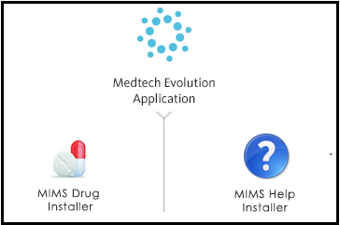
Chapter 4: Configuration
The MIMS Help directory has to be configured before running the MIMS Installer.
Help About About MIMS MIMS Help Config
The MIMS Help File Configuration screen opens up. The path can be configured in this screen.
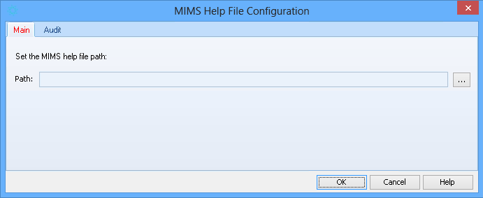
If the path has not been configured, the following error message will be shown during the installation.
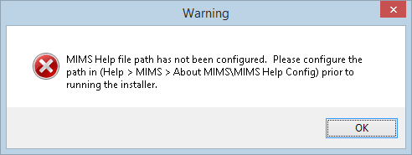
Important Note
In order to have this feature available, it should be enabled for the role corresponding to the Staff. This is shown in the image below.
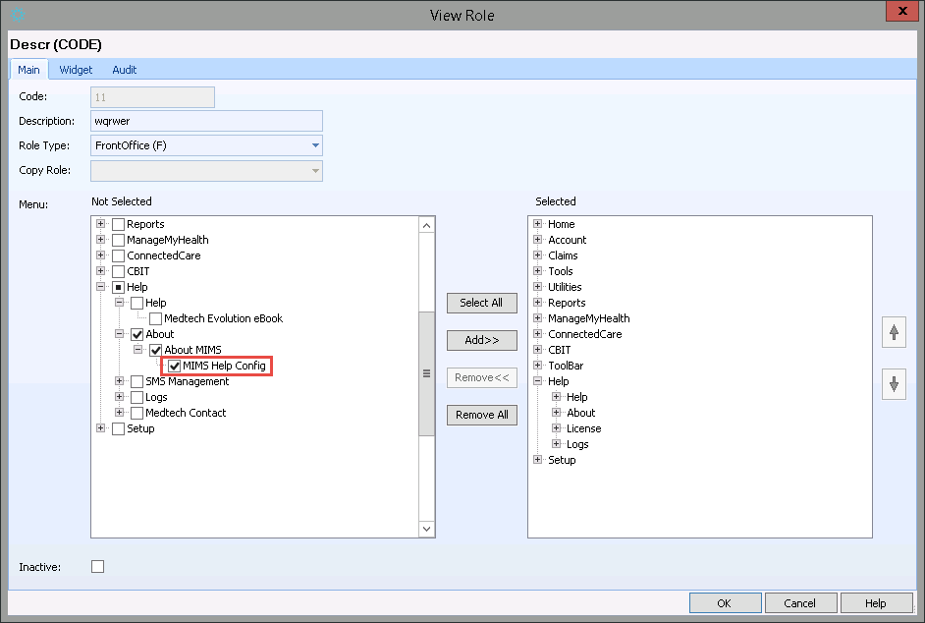

Chapter 5: Installation Guide

Installing MIMS
- Ensure that you have completed and checked all items in the Installation Pre-Requisites Checklist.
- Log on to the machine running Evolution Application
- Locate and double click on the Evolution_MIMSDrug_update.exe to launch the installation wizard.

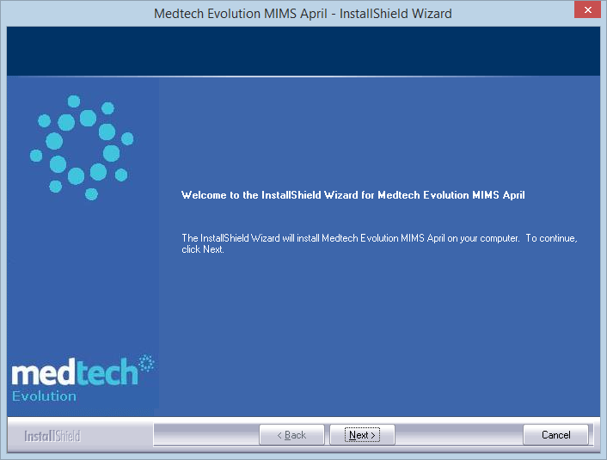

- Click the ‘Next’ button to continue

- The License Agreement screen will appear

- Read through the terms and click I accept in order to proceed with the upgrade

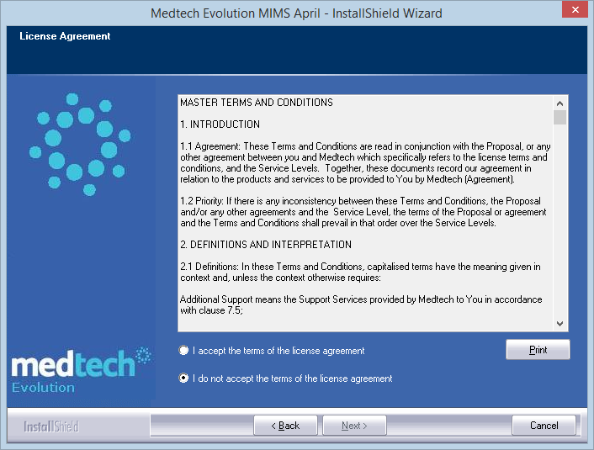

- Click on Next Button to install the MIMS Server program. The window displays the status update

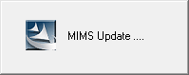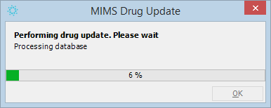

- Click Finish button to complete installation

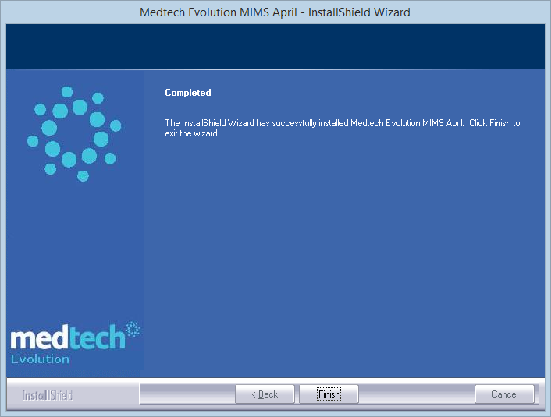

Chapter 6: Post Installation Checklist

1. | Check the current Evolution installed version [Help About MIMS]. After the upgrade has been run, Issue Date should be display as first date of current month
2. | Check whether current month mims.mtd and help file replaced in respective path (“%shared folder% DrugUpdateFile\ mims.mtd” & %Shared folder% \ (help files)
3. | Please ensure that the following utilities are executed  - MIMS Server
4. | Please ensure that all latest drugs are updated
5. | Any errors encountered during the upgrade process shall be recorded and provided to Medtech Support for assistance.
6. | Make sure that the login user has the Administrative permission on the computer in which you are installing the MIMS.
For further information, or any other queries regarding the changes in this release, please contact Medtech Support as follows:
- Via the Medtech application [Help ► Contact Support]
- By email to support@medtechglobal.com
- By fax to 0800 MEDTECH (633 832)
- By phone on 0800 2 MEDTECH (633 832)

